
VCC Payment Issues

A provider may be unable to charge the Virtual Credit Card (VCC) we send for payment. This can happen for several reasons:
- The provider cannot locate the VCC details,
- The VCC has insufficient funds loaded to cover the charge, or
- The VCC is not yet active because the loading time is set for a future date.
In these cases, the provider contacts us to resolve the issue so that payment can be processed correctly.

The first step to take is to make use of the VCarly app:

The app can be found on Teams

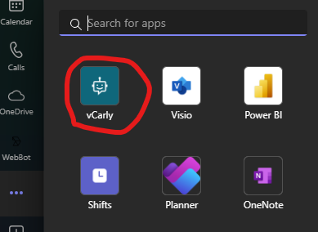

After you found it, you can right click on it and Pin it so you will find it easier.
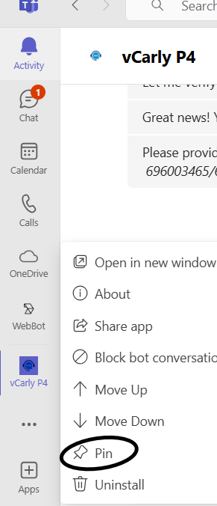

To activate the application, you always must write a greeting like “hi” or “hello”

You will get the following message:

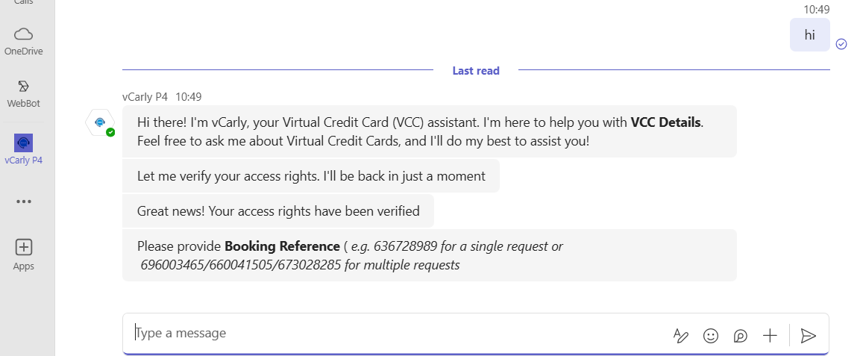

vCarly will validate the format of the booking reference. If the booking reference provided is invalid, you will receive an error after you access the link. The below print screen will appear if you introduce the reference in the correct format.

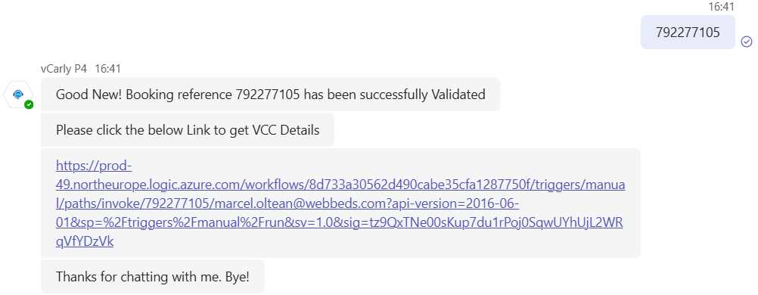

When you provide the correct booking reference Dexter will display VCC Details request, including a secured URL with the VCC Details Link and a Pass Code Link Request. The Pass Code is needed to access the VCC Details.
For DOTW you must provide the booking reference using only the digits and for Maker you need to provide the entire booking reference using the SH letters as well.

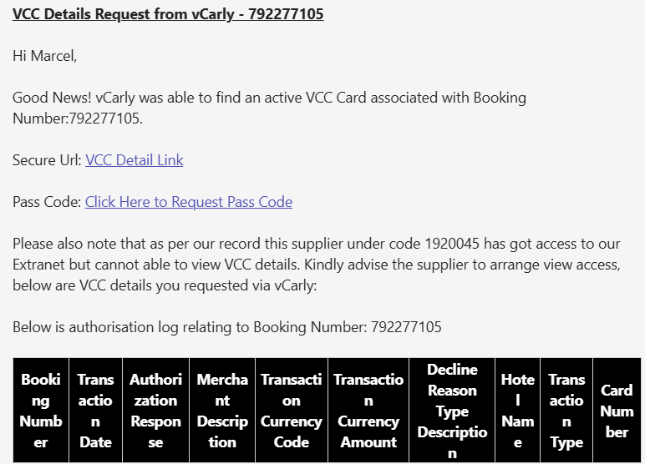

Here you will be able to see all the details for the VCC in order to help you with solving the issue.

Before acting on any of the below scenarios, make sure that the booking can be confirmed while we are working on the case by asking the provider. If it cannot be confirmed, the case must be passed to L2.

- The provider cannot locate the VCC details

Steps:
- Forward the email to the relevant VCC department and ask them to re-send the VCC to the provider.
- VCC Teams per territories (provider side)
- USA | - vcc.usa@webbeds.com
- MEA | - vcc.meaicis@webbeds.com
- APAC | - vcc.apac@webbeds.com
- EUR | - vcc.eur@webbeds.com

- The VCC has insufficient funds loaded to cover the charge

Steps:
- Check with the provider the amount they are trying to charge and compare it to the amount the VCC is created for:
  - If the provider is trying to charge more than the amount loaded on the VCC, push back to them mentioning the actual sum of the VCC and ask the amount they are trying to charge it for.
  - If the provider is asking for more than the amount loaded on the VCC even after the previous step, then the case is considered a rate error and the case should be passed to L2.

- The VCC is not yet active because the loading time is set for a future date

Steps:
- Check the loading time of the VCC using VCarly and inform the provider of the same, asking them to charge it on the date of loading.

